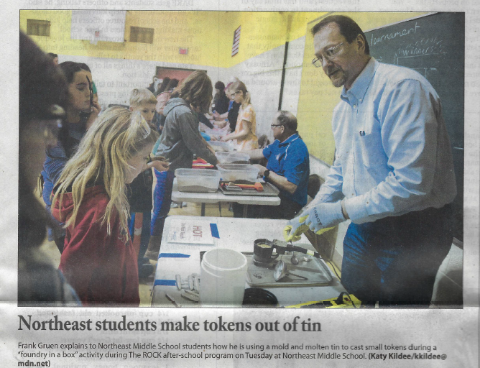

Midland Daily News
February 7, 2018

