AFS Saginaw Valley Chapter Foundry in a Box 2025-2026 events

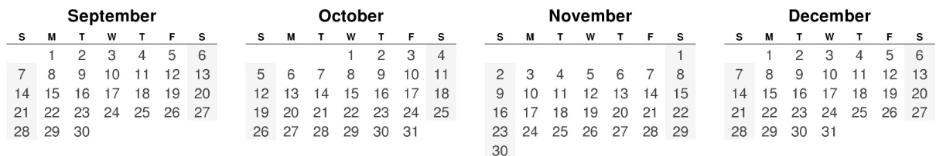
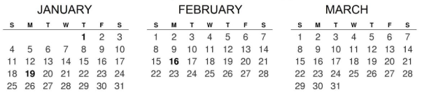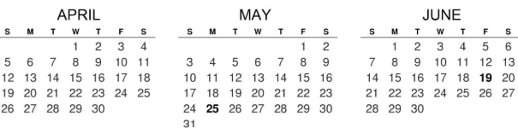
Confirmed date tentative date After School Event Easter is April 5, 2026

Scheduled
AFS Metalcasting Congress FIB Booth Wed-Thurs April 15-16 from W 9:00-4:30, TH 9:00-11:30 AM
Hemmeter Elementary SPARK Day Friday, April 24 from 9:30 AM to 11:30 AM

Completed
SVSU Open Foundry Night w Peg Jones Thursday Sept. 25 from 4:00 -6:00 PM 29 students
Saginaw Career Complex Wednesday, Oct 22 8:00 AM to 12:00 PM
Delta College Girls Day Out 7th-12th grades Friday, November 7 from 8:00 AM to 1:30 PM
Midland STEM after school Wednesday, January 14 from 3 to 5 PM
Bay City Handy Middle School 7th grade Wed-Thurs Feb 11 & 12 from 7:30 AM to 2:00 PM
Clarkston Maker Faire (aid DTW AFS) Cancelled Sat., April 11 8:30 AM to 1:00 PM (est. 300 girls)
Haven Elementary 4th graders Thursday, March 12 from 8:30 AM to 3:00 PM
Bay City Western Middle School 7th grade Mon-Tues March 16 & 17 from 8:30 AM to 2:05 PM
Carrolton Elementary 5th graders Wednesday, March 25 from 7:30 AM to 12:30 PM

