AFS Saginaw Valley Chapter Foundry in a Box 2023-2024 events

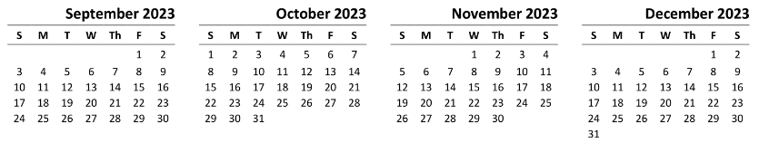
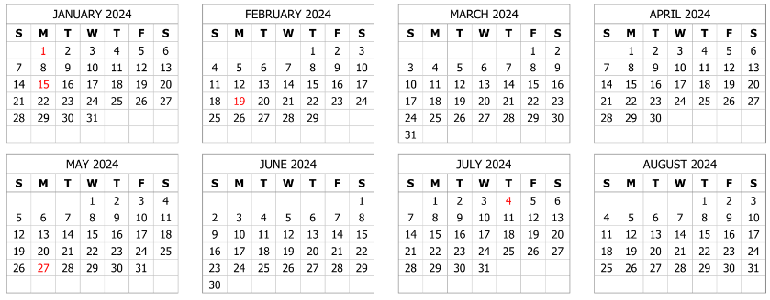
Confirmed date tentative date Easter is March 31, 2024 After School Event
Scheduled
SVSU Open Foundry Night w Peg Jones Friday Sept. 29 from 6:00 -8:00 PM up to 50 students expected
Girl Scout Council STEM Badge Day Sat., Nov 11 from 8:00 AM to 12:30 PM at SVSU (20 girls x 3 sessions)
Freeland Elementary 5th graders Monday November 20 from 7:30 AM to 2:30 PM
Havens Elementary 4th grader Tuesday in January 16 from 9 AM to 3 PM
Bay City Handy Middle School 7th grade Wed-Thurs March 6 & 7 from 7:54 AM to 12:05 PM
Bay City Western Middle School 7th grade Tues-Wed March 19 & 20 from 9:00 AM to 2:05 PM
Clarkston Maker Faire (aid DTW AFS) Saturday, April 13 from 7:30 AM to 4:30 PM (est. 525 girls)
Hemmeter Elementary SPARK Day Friday, April 26 from 7:30 AM to 11:30 AM

Prior Year
The ROCK Meridian Junior High, Midland March 20 from 3:00 PM to 5:00 PM
Bethlehem Lutheran 6th, 7th, 8th grades March 22 from 10:00 am to 12:00 PM
The ROCK Northeast Middle School, Midland April 5 from 3:00 PM to 5:00 PM
The ROCK Jefferson Middle School, Midland April 10 from 3:00 PM to 5:00 PM
The ROCK Community Center, Midland April 24 from 3:00 PM to 5:00 PM
Trinity Lutheran School, Bay City Friday, May 26 8-11 AM

Cancelled
Nouvel Catholic Central Elementary Friday, May 19 from 8:00 AM to 3:00 PM (est.) cancelled 3/24

In Planning Stage
Havens Elementary 5th graders

