AFS Saginaw Valley Chapter Foundry in a Box 2015 events

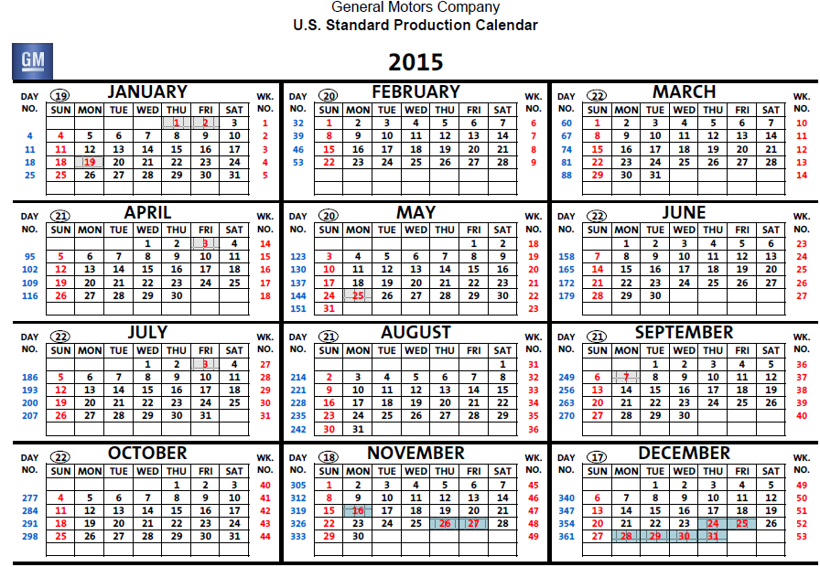

Freeland Monday January 12 5th graders – 6 sessions 9:50 AM to 3:10 PM – provide 5+6 adults from schools
Bay City Western 8th graders Thursday January 29th 6th to 8th graders 5 sessions 8:45 AM to 2:17 PM
Hemetter Elementary Friday Feb. 27th -5th graders three morning sessions (25 students/ session) (J. Garcia)
Sterling Elementary School Thursday, March. 12th -4th &5th graders four sessions (28/ session) 9 AM – 12 PM
Millington High School Wednesday, March 18th Science class 12-4 PM (Renee Mietz)

Millington Girl Scouts Monday, April 13 Girl Scout Troops 5:30 to 7:30 PM (Renee Mietz)

AFS Casting Conference in Columbus, OH Wednesday, April 22 from 1-5 PM

Nouvel Elementary in Saginaw Township Friday, April 24 from 8 AM to 2 PM (4-6th grade students) (Brian Smith)

Stone Elementary in Saginaw -Tuesday, May 12th (DJ Couture)

Midland Cub Scout pack 20-30 youth May 2015 in evening (Ed Wall)

SciFest at Delta College Sept 25-26, 2015

Mini-Materials Camp” at an ASM Heat Treating and the American Gear Mfg Assoc. Show & Conference
Oct. 21-22, 2015 at Cobo Hall (Peggy Jones)

There’s also a student “Mini-Materials Camp” at an ASM Heat Treating and the American Gear Manufacturing Association Show & Conf Oct. 21-22, 2015 at Cobo Hall. This event is usually 4 sessions spread over 2 days, between 9 and 2, with each session offering 8 activity stations in an area in on the trade show floor. Kathy Hayrynen and I ran the materials camp at Cobo in 2007. Tom Cobett provided the FIB station for it. We had about 250 kids over the 4 sessions. I would love it if DW AFS can send a volunteer and equipment for this – Kathy’s working on that, but if worse comes to worse I may borrow some flasks and patterns from our kit.

