http://www.metalshipper.com/tin-nugget-1-pound.html
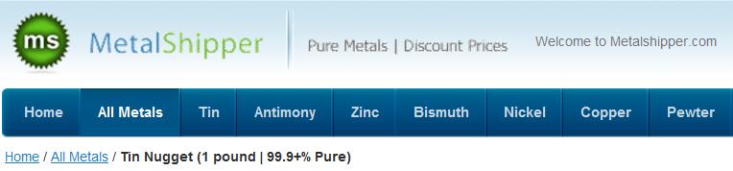
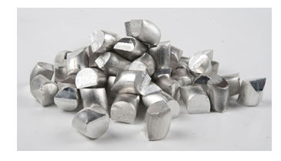

Quick Overview
Our Tin Nugget is all sourced directly from the Minsur mine in Peru where they are produced and is 100% “virgin” metal (not recycled). We sell this metal by the pound, so if you need 10lbs, simply add a quantity of 10 to your cart. Be sure to see our bulk discounts for certain quantity levels if you would like to save money per pound. If you are interested in making a very large order, please contact us directly for pricing and availability. * Please Note: Due to the irregular shape of this metal, the weight of your shipped order is approximate. It may be up to 5% over or under the exact amount ordered. Meets ASTM B339 specification. All metal shipments come with a certificate of analysis.* Atomic Number = 50 | Melting Point (F) = 450 | Atomic Mass= 118.71 | Boiling Point (F) = 4100 | Density (g/cm³) = 7.29 |

Phone: (484) 713-5898 (10am - 4pm EST)

