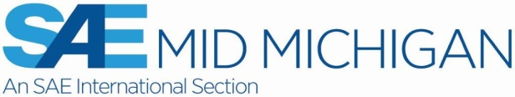  Purchase Tickets online at: http://www.midmichigansae.org | Mid-Michigan SAE Programs with Dinner for 2016  SAE ticket pricing as shown on the MMSAE website http://www.midmichigansae.org  For more information contact SAEMidMichSec@cs.com

 | "Bearing Failure Analysis"  Speaker: Dean Thayer  Program Chair: Mark Pope & Peg Jones – A scheduled SVEC event  Monday, March 14, 2016  Holiday Inn, 5353 Gateway Center, Flint, MI 48507  6:00 PM Social Hour  7:00 PM Dinner  8:00 PM Program

Reservations required by Wednesday, March 09, 2016 by eMail SAEMidMichSec@cs.com

Ticket pricing for ASM and AFS members is $35 for member & spouse/guest.
Additional pricing …. Students $20 …… Retirees $30 …… NonMembers $40
Purchase tickets online at http://www.midmichigansae.org (preferred method) or at door
with credit card (check or cash at door also).

Abstract:
The calculation of bearing life is based on the basic fatigue life of the bearing steel and certain assumptions of its usage conditions within the application. However, many times bearings do not achieve their calculated life, in effect suffering an early life failure. These early life failures are usually the result of unanticipated usage conditions, contamination, improper bearing installation, handling issues, poor maintenance, and improper lubrication methods. In this talk we will quickly review the bearing life calculation, bearing lubrication, and address many of the common bearing failure modes and causes.

Dean Thayer bio:
Senior Development Engineer in the Materials and Development Department, NSK Corporation – 10 years
Major responsibility is conducting bearing failure investigations and analysis
Seventeen years prior to NSK working in the automobile supplier industry as a Mechanical Engineer, often with bearing specification and release responsibility

Mid-Mich SAE extends an invitation to ASM/AFS members to attend our Camaro event.
 | "2016 Chevrolet Camaro"  Speaker: Al Oppenheiser, Chief Engineer, GM  Program Chair: Mark Pope  Monday, April 25, 2016  Bavarian Inn Lodge Conference Center, Frankenmuth, MI  6:00 PM Social Hour  7:00 PM Dinner  8:00 PM Program

